Microservices Technical Report 1

System Overview
The system is an e-commerce order fulfilment application built using a microservices architecture. The domain naturally decomposes into three distinct responsibilities; stock management, payment processing, and confirming the order, so each of these is handled by its own dedicated service.
When a user wants to place an order, they send a request to the Order Service through a REST API. The Order Service does not call the other services directly; instead, it published an event to a message broker (Kafka), and the Inventory, and Payment services each react to that event independently. The client can also query the Order Service at any time to check the status of their order, and see a full history of everything that has happened to it.
The system is also built to handle failures cleanly. For example, if a payment is declined after stock has already been reserved, the system will automatically release that reservation rather than leaving it locked. This is handled using compensating actions as part of a Saga pattern, which ensures the system does not end up in a broken, or inconsistent state when something goes wrong.

Architecture
The system is made up of three microservices, each with its own respective responsibility, and its own isolated database.
The Order Service is the entry point for users. It exposes the REST API build with FastApi, which allows users to place orders, and check their status. It stores data in Redis using two separate keys: a write model (order:{id}) which holds the raw order record, and a read model (order_summary:{id}) which is used to serve queries.
The Inventory Service handles stock management. When an order comes in, it checks whether enough stock is available, and reserves it if so. It stores stock levels, and reservations in its own Redis instance, using keys like stock:{product_id} and reservation:{order_id}:{product_id}. If a payment later fails, it uses these reservation records to know exactly how much stock to release.
The Payment Service is responsible for processing payments. It receives an event telling it that stock has been reserved, then either approves, or rejects the payment depending on the order total. The outcome is saved to Redis under payment:{order_id} and published back to Kafka so the rest of the system can react.
Rather than calling each other directly, the three services communicate entirely through Kafka events. This means the services are loosely coupled; the Inventory Service, for example, has no direct knowledge of the Order Service. It simply listens for order.created events, and responds to them. Because each service has its own Redis instance, it means that they share no data storage.

Distributed Data Patterns

Saga Pattern
The core problem this pattern solves in this system is that each service has its own database, so there is no shared transaction that can be rolled back if something goes wrong mid-order. Instead, the workflow is broken into a chain of local transactions, where each service reacts to the previous service's event. This system uses choreography, meaning no single controller directs the flow. Each service listens for the events it cares about, and acts on its own. In the happy path, when a user places an order, the Order Service publishes order.created, the Inventory Service reacts by reserving stock, and publishing inventory.reserved, the Payment Service then processes payment, and publishes payment.succeeded, and the Order Service marks the order as COMPLETED. When payment fails, the Payment Service publishes payment.failed instead. Two things happen in response: the Order Service picks this up in saga_listener.py, and marks the order as cancelled, and the Inventory Service picks it up in the handle_payment_failed function inside consumer.py, which releases the stock reservation that was made earlier. This is the compensating action, and it undoes the work already done so the system is left in a clean state.

Transactional Outbox
When an order is created, the Order Service needs to save the order to Redis, and publish an event to Kafka to kick off the saga. The problem is that these are two separate operations so if the service crashes between them, the order is saved but no event is ever published, and the saga never starts. The outbox pattern fixes this by writing both things together in a single atomic operation. In outbox.py, a Redis pipeline with transaction=True uses MULTI/EXEC to write the order record, and an outbox entry to outbox:pending at the same time. Either both are saved, or neither is, so the data is never left in a half-written state. A background loop, run_outbox_publisher, then handles publishing. It picks entries from outbox:pending, moves each one atomically to outbox:processing using LMOVE, publishes it to Kafka, and deletes it. The reason for the two-step move is recovery; if the service crashes while publishing, those entries are still sitting in outbox:processing. On startup, the service moves everything in outbox:processing back to outbox:pending automatically, so no events are lost even after a mid-publish crash.

CQRS
The Order Service maintains two separate Redis keys for each order. The write model, stored under order:{id}, holds the core order data, and is updated directly when an order is created, or its status changes. The read model, stored under order_summary:{id}, is what the client sees when they call GET /orders/{id}. The API never touches the write model for reads. The read model is built and kept up to date by projection.py, which runs as a background consumer. It listens to all order-related Kafka events; order.created, inventory.reserved, payment.succeeded, payment.failed, and so on, and updates order_summary:{id} each time one arrives. This means the summary always reflects the latest state without any computation at read time. The main reason this is useful is the event_log field included in the read model. This is a full timeline of every event the order went through, in order. Reconstructing that from order:{id} alone would require joining data across multiple records on every request. With the read model already shaped for the client, the query is a single key lookup.

Failure Handling
This section walks through three specific failure scenarios, and how the system handles each one.
Scenario 1: When a payment is declined, the Payment Service publishes payment.failed. The Inventory Service picks this up in handle_payment_failed, which restores the stock level, and publishes inventory.released. At the same time, the Order Service’s saga listener marks the order as cancelled. The stock level returns to exactly what it was before the order was placed.
Scenario 2: If the Inventory Service cannot reserve the requested item, it publishes inventory.insufficient instead of inventory.reserved. Because the saga only moves forward when it receives inventory.reserved, no payment is ever attempted. The Order Service marks the order as cancelled immediately.
Scenario 3: If a service crashes after writing to the outbox but before the event is published to Kafka, the event remains in outbox:processing state. On the next start up, the service moves everything in outbox:processing back to outbox:pending, and the publisher loop picks it up again.

API Description
The system exposes three APIs across the Order Service, Inventory Service, and the Payment Service. POST /orders accepts a customer ID, and a list of items with quantities, and prices. The request body, and response are shown below:
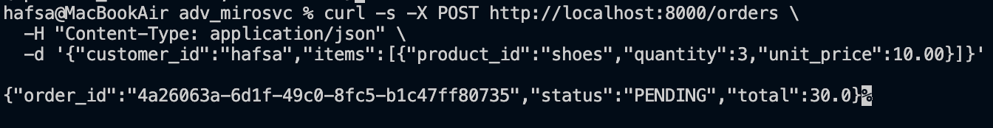
GET /orders/{order_id} return the status of an order, and a full event log showing every stage the order passed through. The following shows the status of a failed order:
GET /stock/{product_id} returns the current stock level for a product. This can be called before, and after an order to confirm that stock was decremented, or restored.
GET /payments/{order_id} returns the payment outcome recorded by the Payment Service, including whether it succeeded or failed, and the reason. The following shows the outcome of a successful payment:

Successful Order
To test the happy path, I placed an order for 3 pairs of shoes at 10$ each giving a total of 30. Before placing the order, the stock was at 100, and after it dropped to 97, which confirmed the Inventory Service reserved the 3 items. The Payment Service approved the payment since the total was below the payment threshold, and the order eventually reached a status of completed. The logs below show the successful Saga chain across all three services in order:
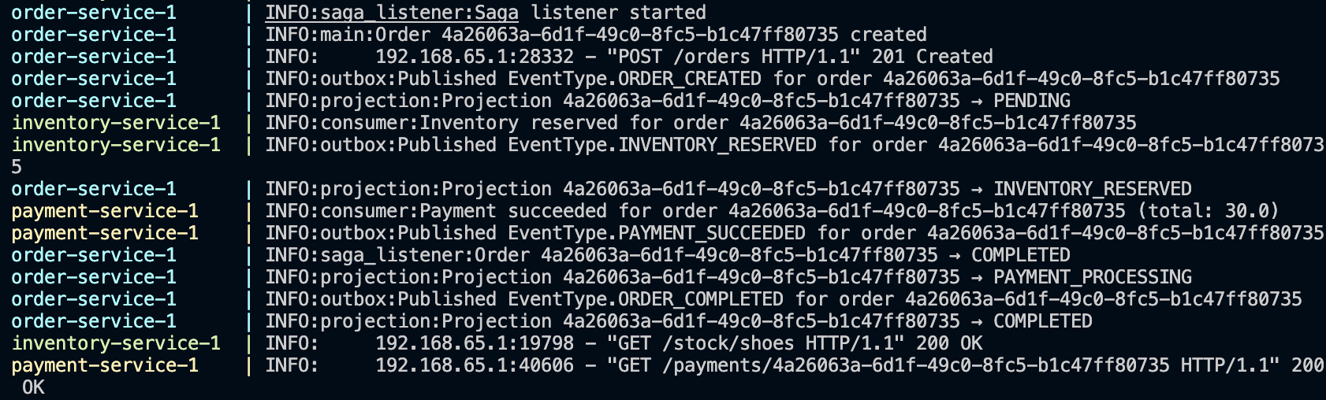
Curl commands showing the full process:
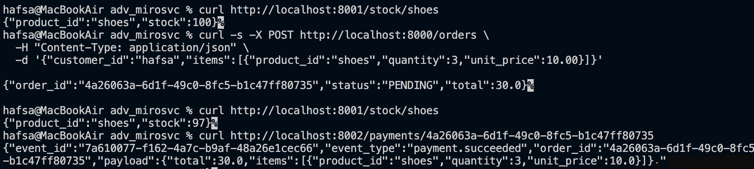

Failed Order
To test the failure path, an order above the payment threshold was placed. The Inventory Service reserved the stock as normal, but the Payment Service rejected the payment because the total exceeded the payment limit that was created. At this point, the compensating actions run automatically; the Inventory releases the reservation, and the Order Service marks the order as cancelled:
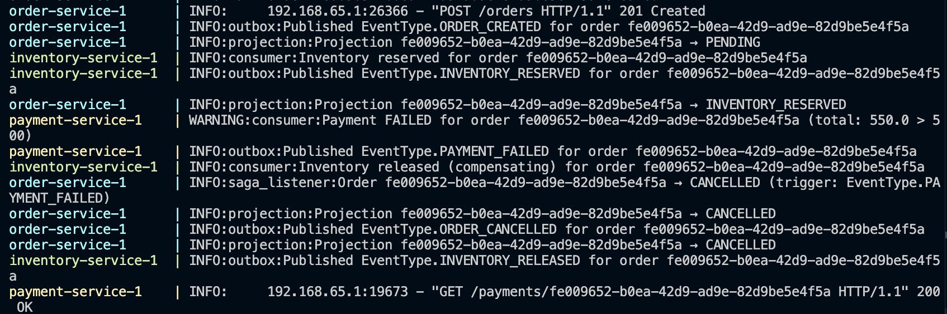

Curl commands showing the full process:
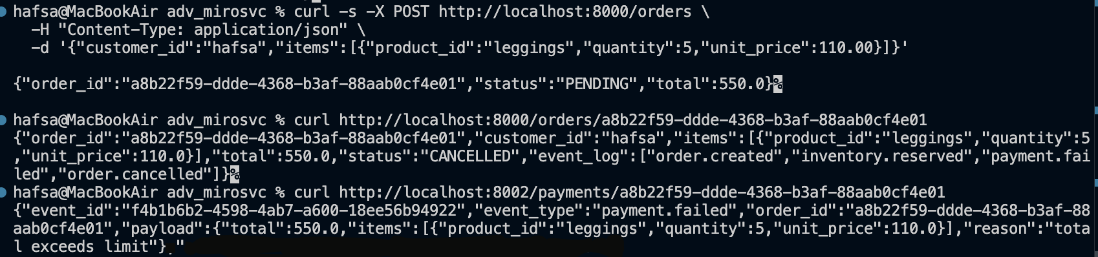

Use of AI
I used AI during the development of this project to help implement parts of the system. Some of the prompts used are documented below:
Prompt 1 – Initial Setup
This was used to get the initial project structure set up; the Docker Compose file, the three services, and the Kafka, and Redis configurations:
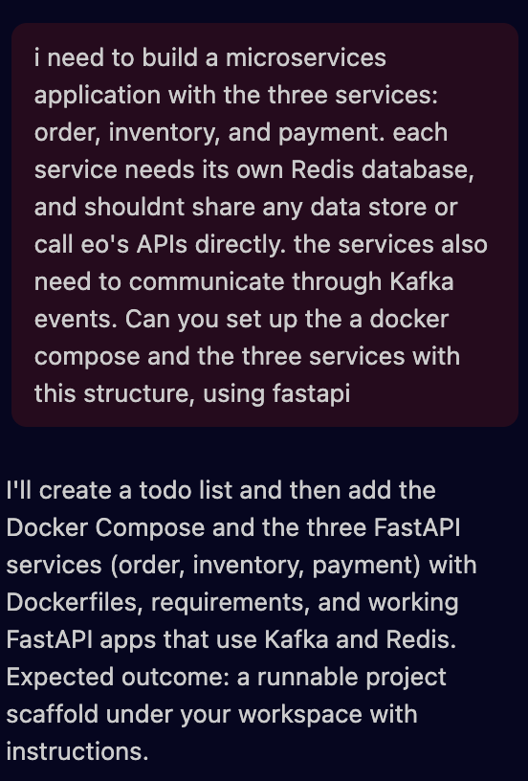
Prompt 2 – Saga Pattern
This was used to implement the Saga pattern across the three services. I defined the event flow prior to the code generation based on my specific domain:
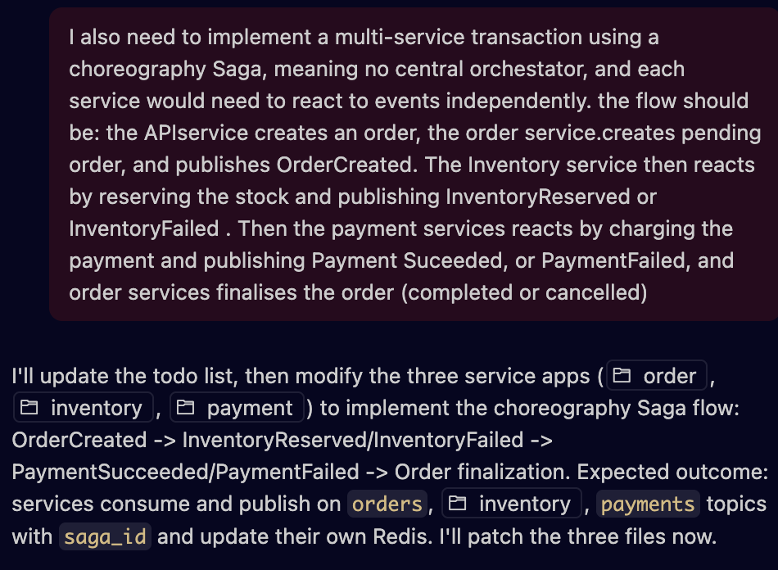
Prompt 3 – Dual-Write Problem
This was used to understand the risk within my specific system so I could later implement the outbox pattern appropriately:
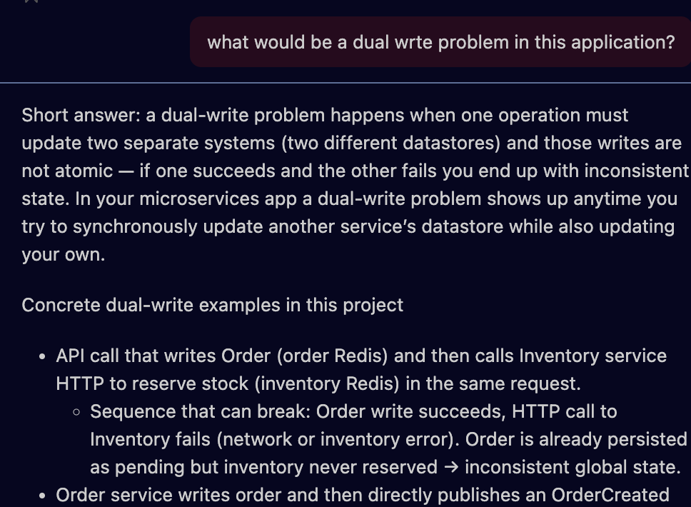
Prompt 4 – Transactional Outbox Pattern
This was used to implement the outbox pattern once I understood where I needed to resolve the problem:
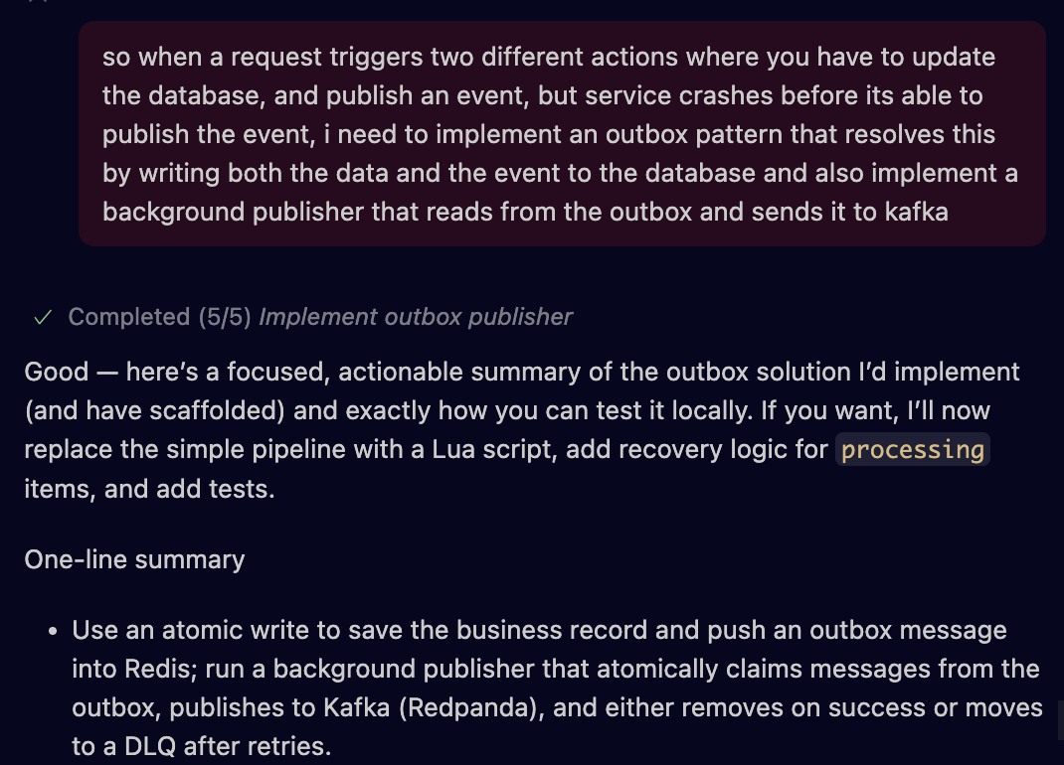
Prompt 5 – CQRS
This was used to implement the CQRS pattern in the Order Service. I specified what each model should contain, and how they should stay in sync before asking for the implementation:
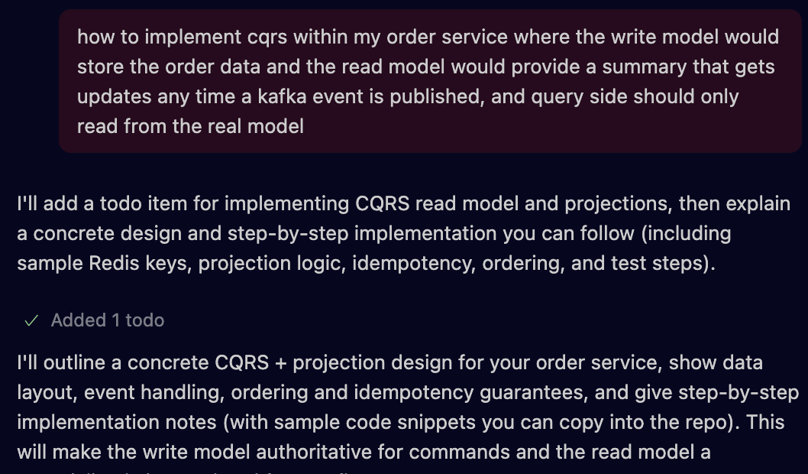
All generated code was reviewed, and tested manually by running the full saga flow, and verifying the results through the API responses, and service logs.

